**Activity #4**

**PART 1**

**Compound adjectives are formed in different ways. Find 2 examples for each type of compound adjective. DO NOT use the examples in the image**

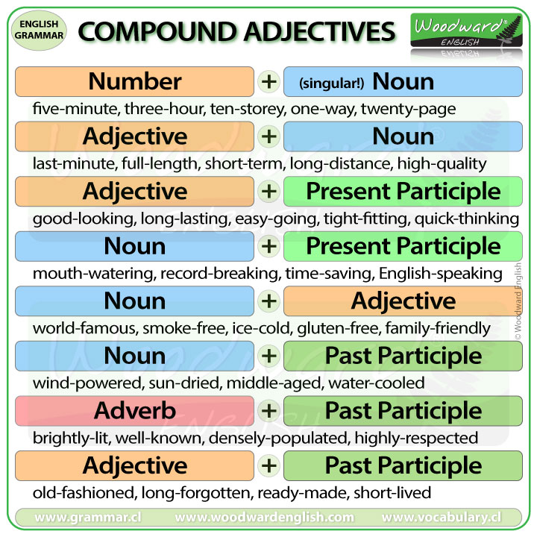

**Number + Noun**

* **Long-distance.**
* **Nine-page.**

**Adjective + Noun**

* **First-minute.**
* **Short-time.**

**Adjective + Present Participle (word with “-ing”)**

* **Long-running.**
* **Loud-speaking.**

**Noun + Present Participle (word with “-ing”)**

* **Meat-eating.**
* **Thought-provoking.**

**Noun + Adjective**

* **Camera-shy.**
* **Sugar-free.**

**Noun + Past Participle (word conjugated in past participle)**

* **custom-built.**
* **User-generated.**

**Adverb + Past Participle (word conjugated in past participle)**

* **Never-ended.**
* **Well-cooked.**

**Adjective + Past Participle (word conjugated in past participle)**

* **Short-haired.**
* **Strong-built.**

**PART 2**

**Instructions:** Write sentences of your own with compound adjectives. Highlight or underline the compound adjective.

For example:

I want a **part-time** job because I am still studying and don’t have a lot of time.

7

1. When my brother got his job, he bought a **brand-new** car.
2. My sister is wearing an **old-fashioned** shirt that belong to my grandmother when she was a child.
3. Our teacher this quarter is a **highly-respected** web designer.
4. Jacob hates when his leader wants to make **last-minute** changes to the project.
5. My cousin brought today his **four-year** son to home.
6. She wanted to buy her daughter the most **child-wanted** computer.
7. Jr. loves to drink an **ice-cold** Dr. pepper of 2 liters.